Team Ate (8)

Scenario Summary: A map-based application that locates and guides users towards important places of interest such as restrooms, water fill-stations, hospitals, etc. The system revolves around the utilization of GPS as well as QR codes to identify locations

Members:

Alexa Wang

Michael Orlanes

David Chen

Tiffany Wu

Date: 02/08/2022

**Alexa Wang**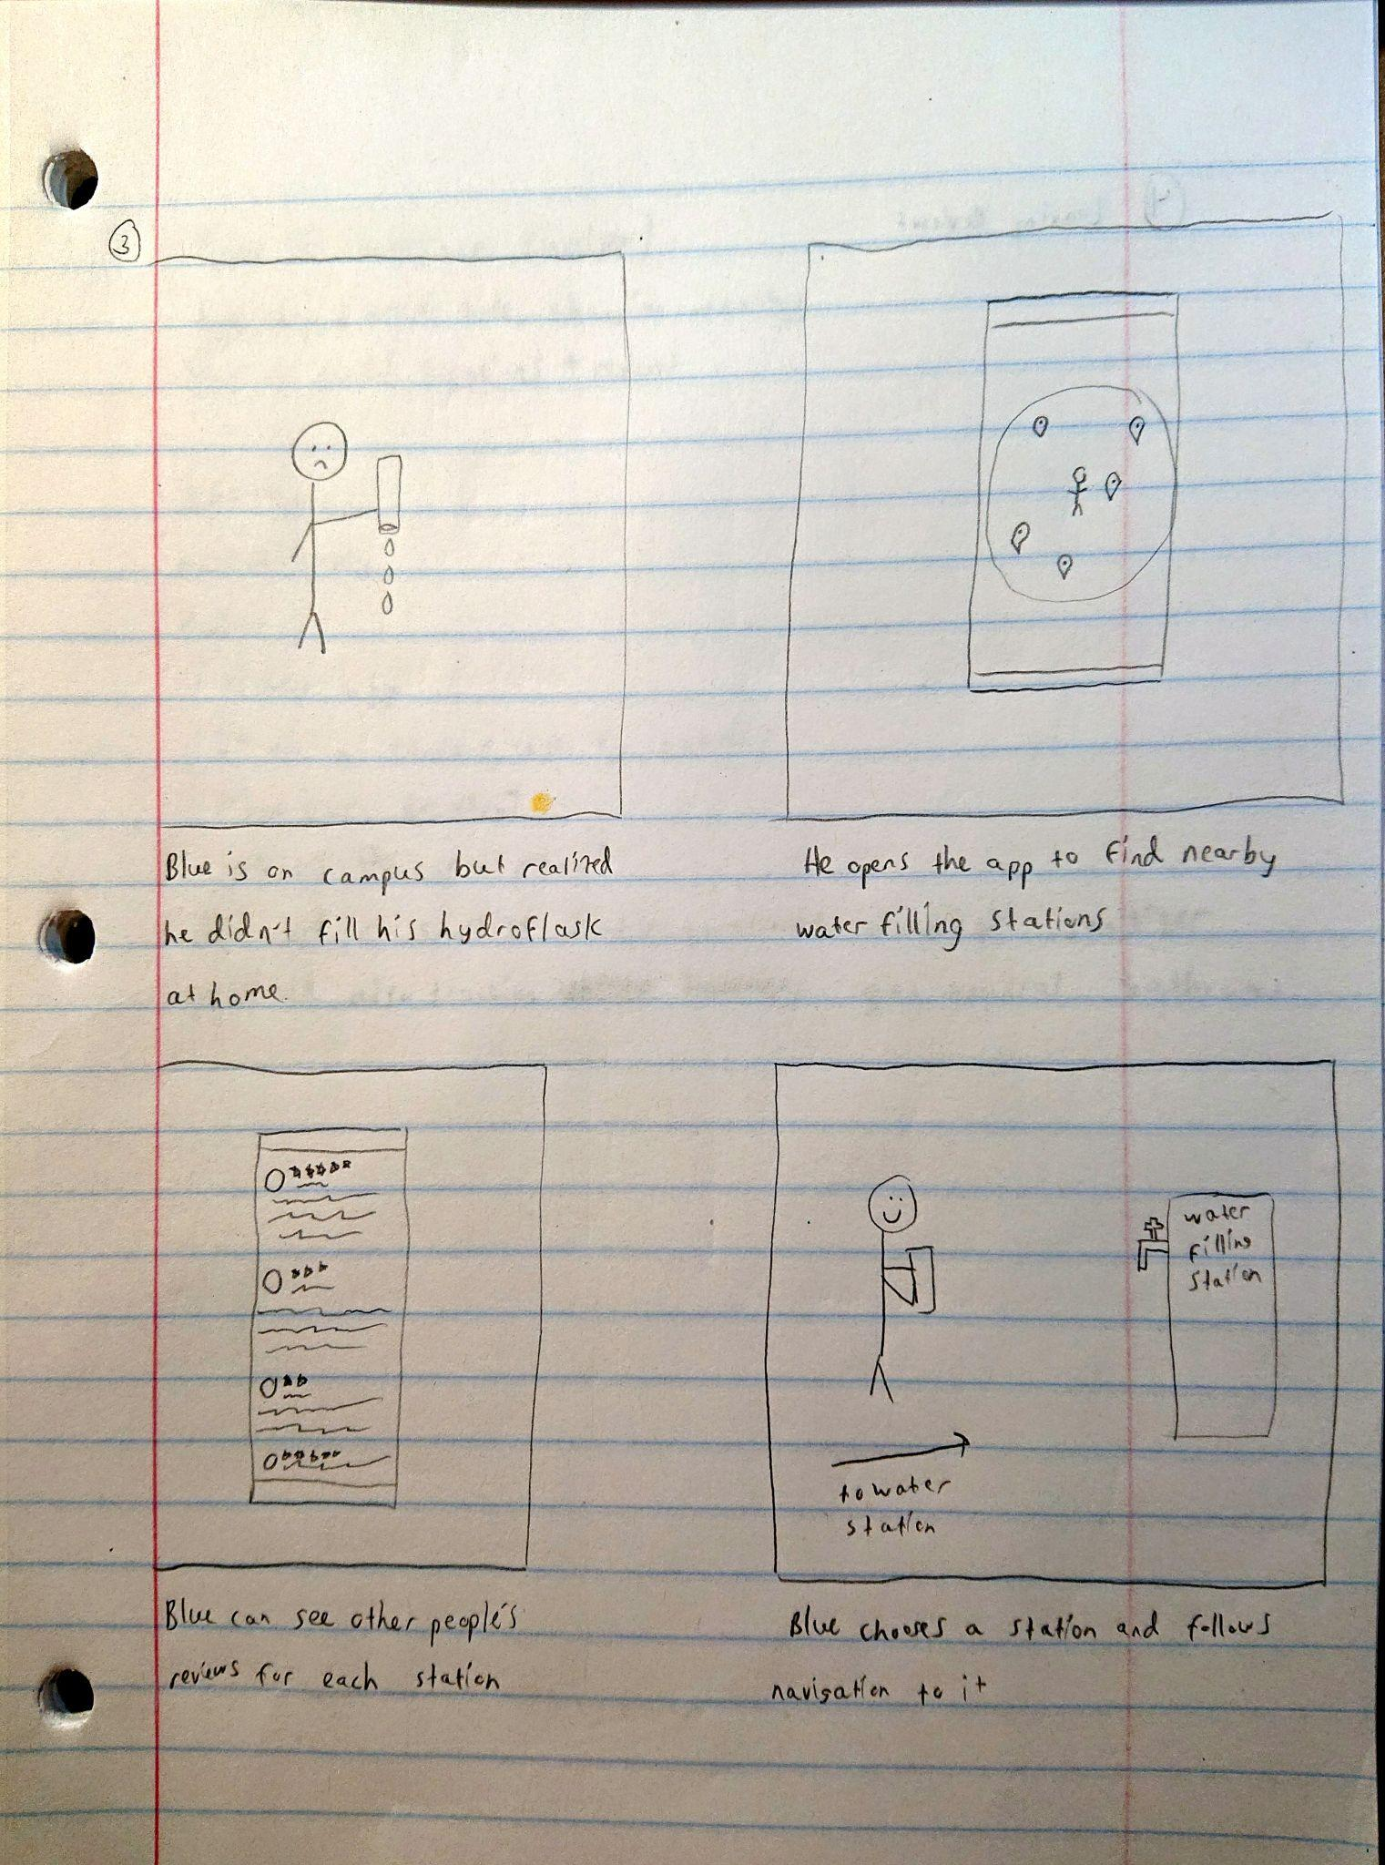

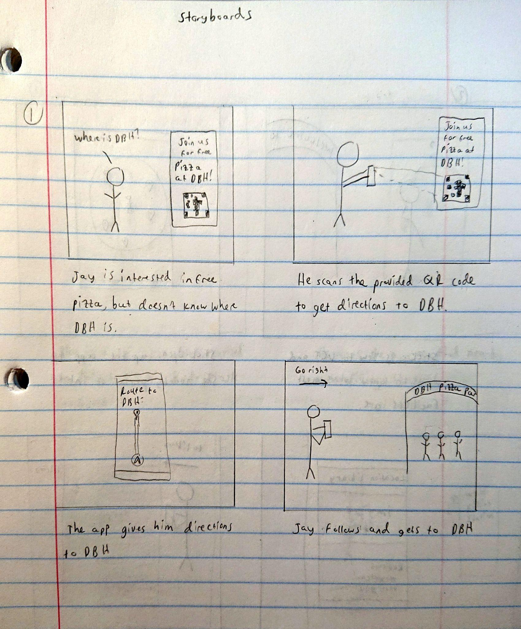

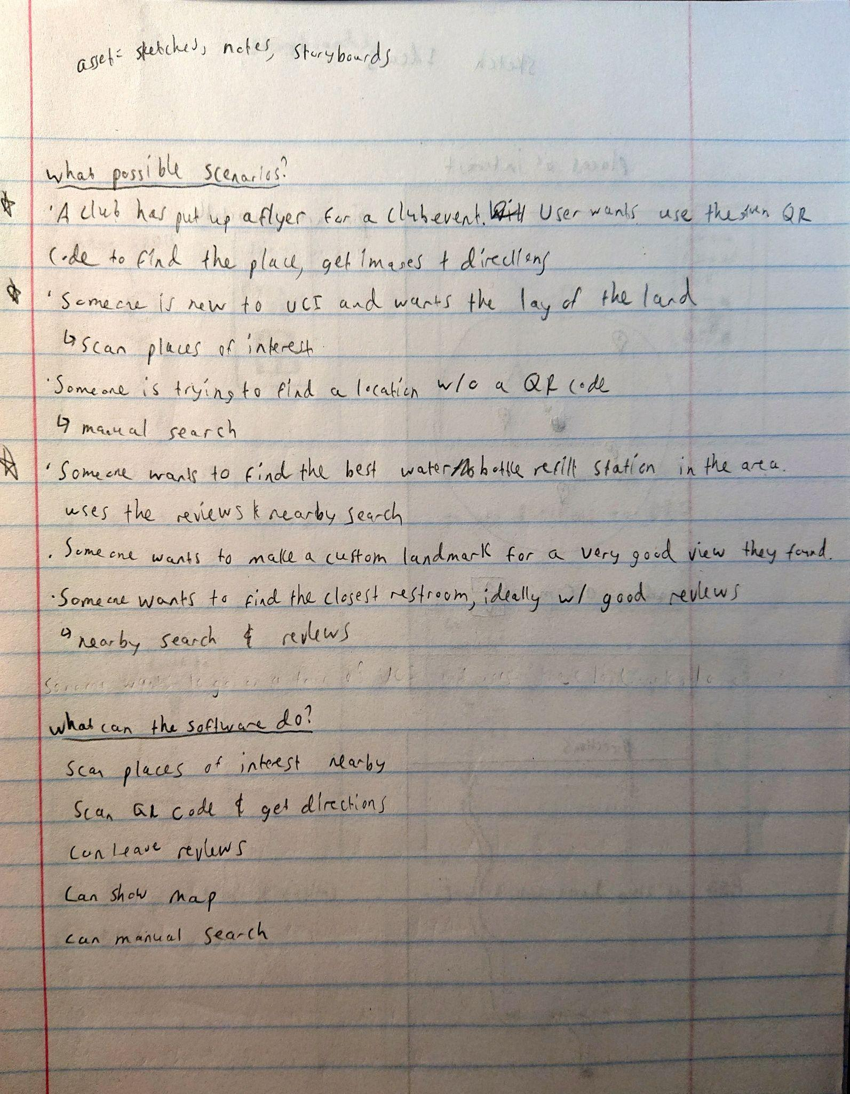

**Tiffany Wu**

|  |  |
| --- | --- |
|  |  |

**Michael Orlanes**

**Artifact #1:** Sketches of the main page and the “landmark browsing” tab

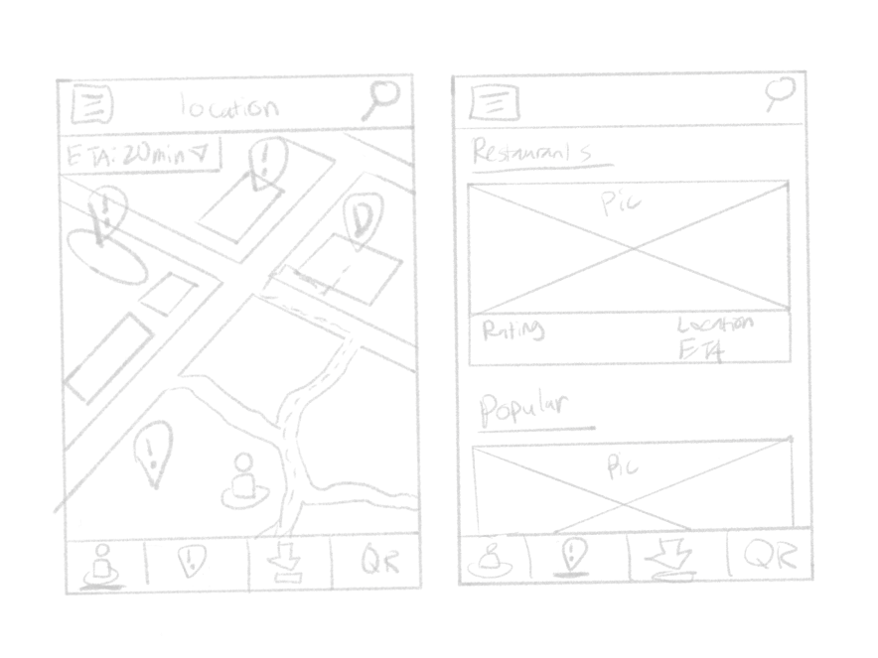

Notes about the design:

* All important landmark locations are marked with “!”
  + “D” is a current placeholder for the intended destination
  + Most likely have a different color/shape from the other icons
  + Some icons might be changed to further specify their purpose (i.e. toilets for restrooms, handicap icon for disabled accessibility, etc)
* User can click on the dropdown of the “ETA” button to see the exact steps to get to the location
* The avatar icon on the bottom is the user’s current location
* The user’s current location address can be posted at the top
  + If not near an address, it can have no text on the top
* Has 4 icons on the navbar on the bottom (for now with placeholder icons)
  + Main menu
  + Browse landmarks
  + Download maps
  + QR scanner
* An underline will indicate what page the user is currently on
* Path to the location (for now) is a dotted highlighted line from the user to the destination
* On the “Browse landmarks” page, multiple entries can be under one heading
  + Can be filtered or searched

**Artifact #2:** A sketch of the potential application icon

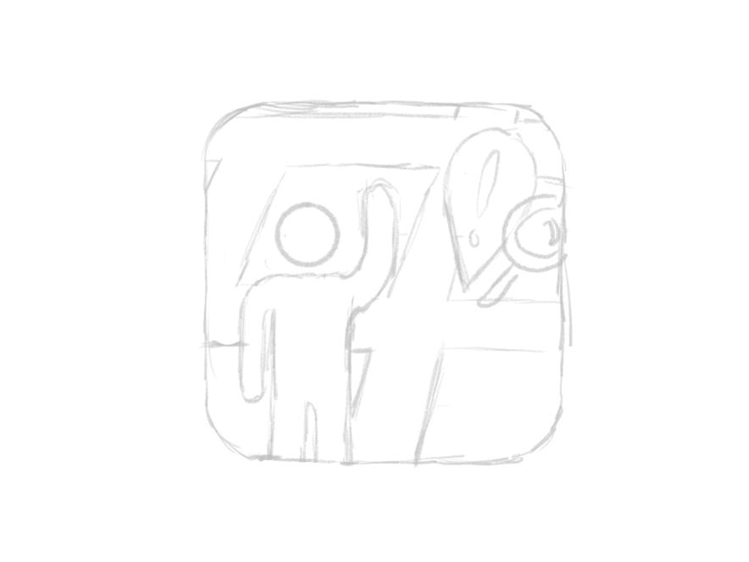

Notes about the design:

* Most universal map apps (i.e. Maps, Google Maps, etc) have a destination marker as the focal point of the design
  + Often scene as the logo or the symbol for a map app
  + Present in the app icon for quick recognition
  + Follows Nielsen #4, Consistency and Standards
* Will most likely include a color scheme that correlates to the will-be agreed color scheme of the app/or the color of the map
* Might change the person it does not wave; might look like a pick-up app such as Uber
* Icons should be big and simple enough so that it does not require squinting to understand the details of the design

**Artifact #3:** Notes about additional ideas to potentially add later in development:

* **Bolded items** are features, in my experience, don’t think I’ve really seen as a big part of other navigational apps
* Being able to see the ratings/quality of locations such as restaurants and bathrooms
  + Links with critic apps such as yelp for such info
  + You can also search/filter for places that have nice quality facilities/food
  + How busy some places can be at what times
* Create an account that can be signed up as part of email
  + Potentially link with other accounts from other places such as a Google Account
  + You can share locations with other people, create QR codes
  + Maybe add comments or ratings to places so other people can see your experiences so they may decide if going to sad place is worth it
* Add a disability filter
  + Only opens paths or finds paths that are open to disabled people (like wheelchairs, crutches, etc)
* Have a “saved” feature that a person with an account (or maybe not) can have personal landmarks they want to access often and quickly
* **Potentially have a “suggest a landmark” feature where users can send suggestions to developers to add landmarks that can be added to the map for everyone to see**
* **Being able to download maps temporarily (only one or two at a time) so when a person who does not have data or internet can still see a map**
  + The map will not show a person’s current location as there is no GPS signal
  + If the person knows in advance that they will not have internet/data access, they can mark up the map in advance
* Have a browse feature which can put in a list (with pictures and small descriptions) of all important locations within a user specified mile radius of their current location
* Have the weather/temperature of where they currently are displayed somewhere on the main HUD
* Options to navigate between different traveling mediums (can be mixed mediums) such as taking a train, biking, flying, etc.
* **Show events that will be taking place in the future on any nearby landmarks that is shown to the user (concerts, gatherings, festivals, etc)**

**David Chen**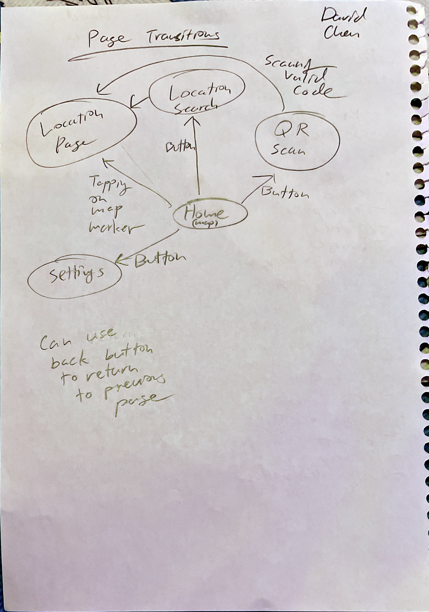

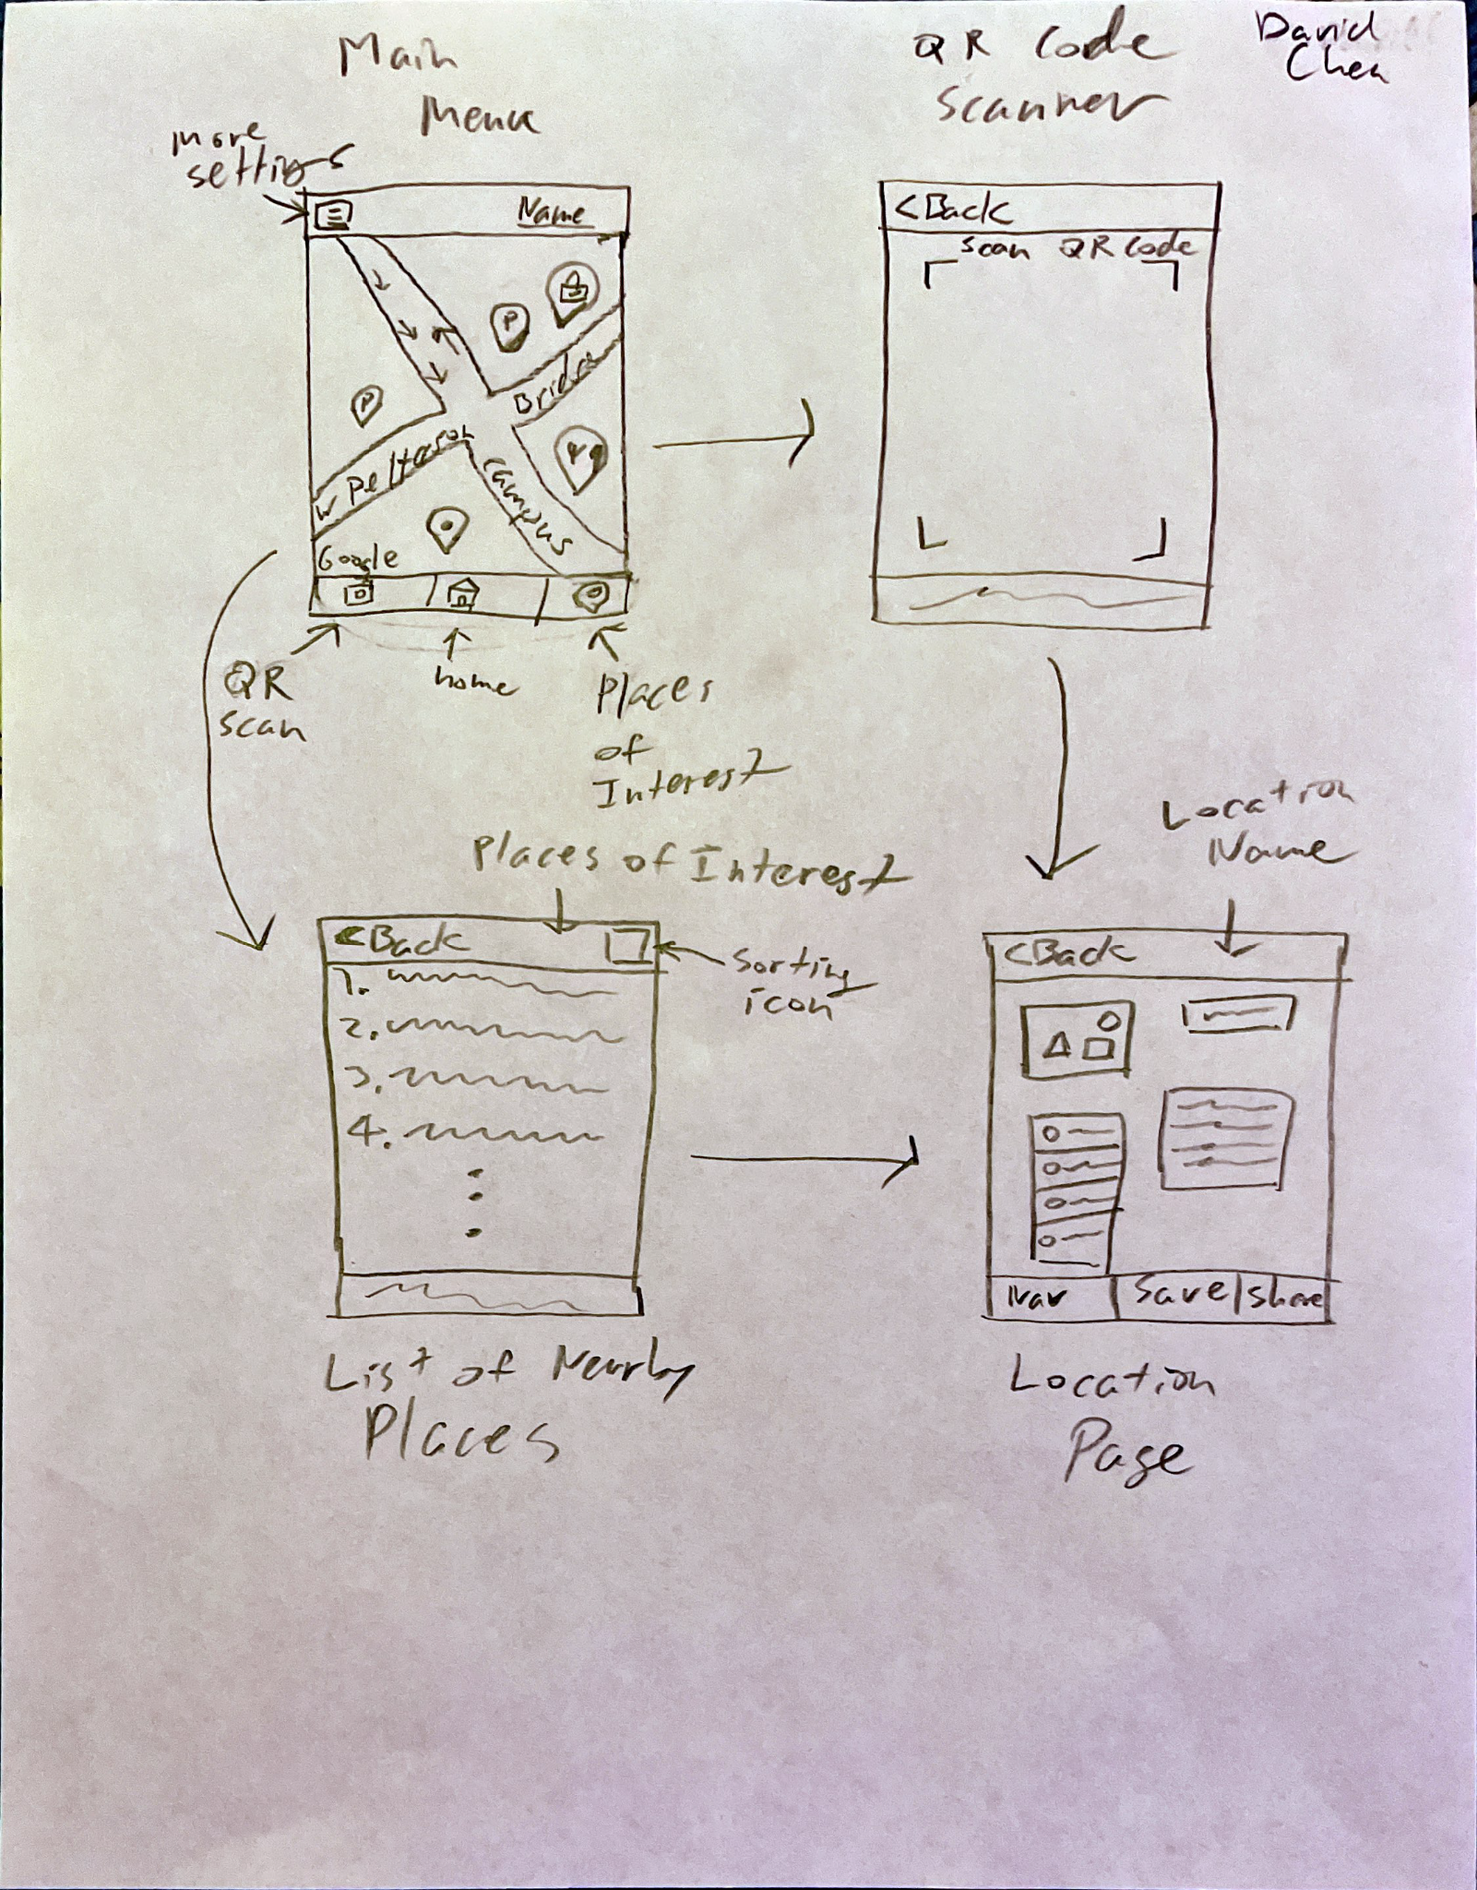

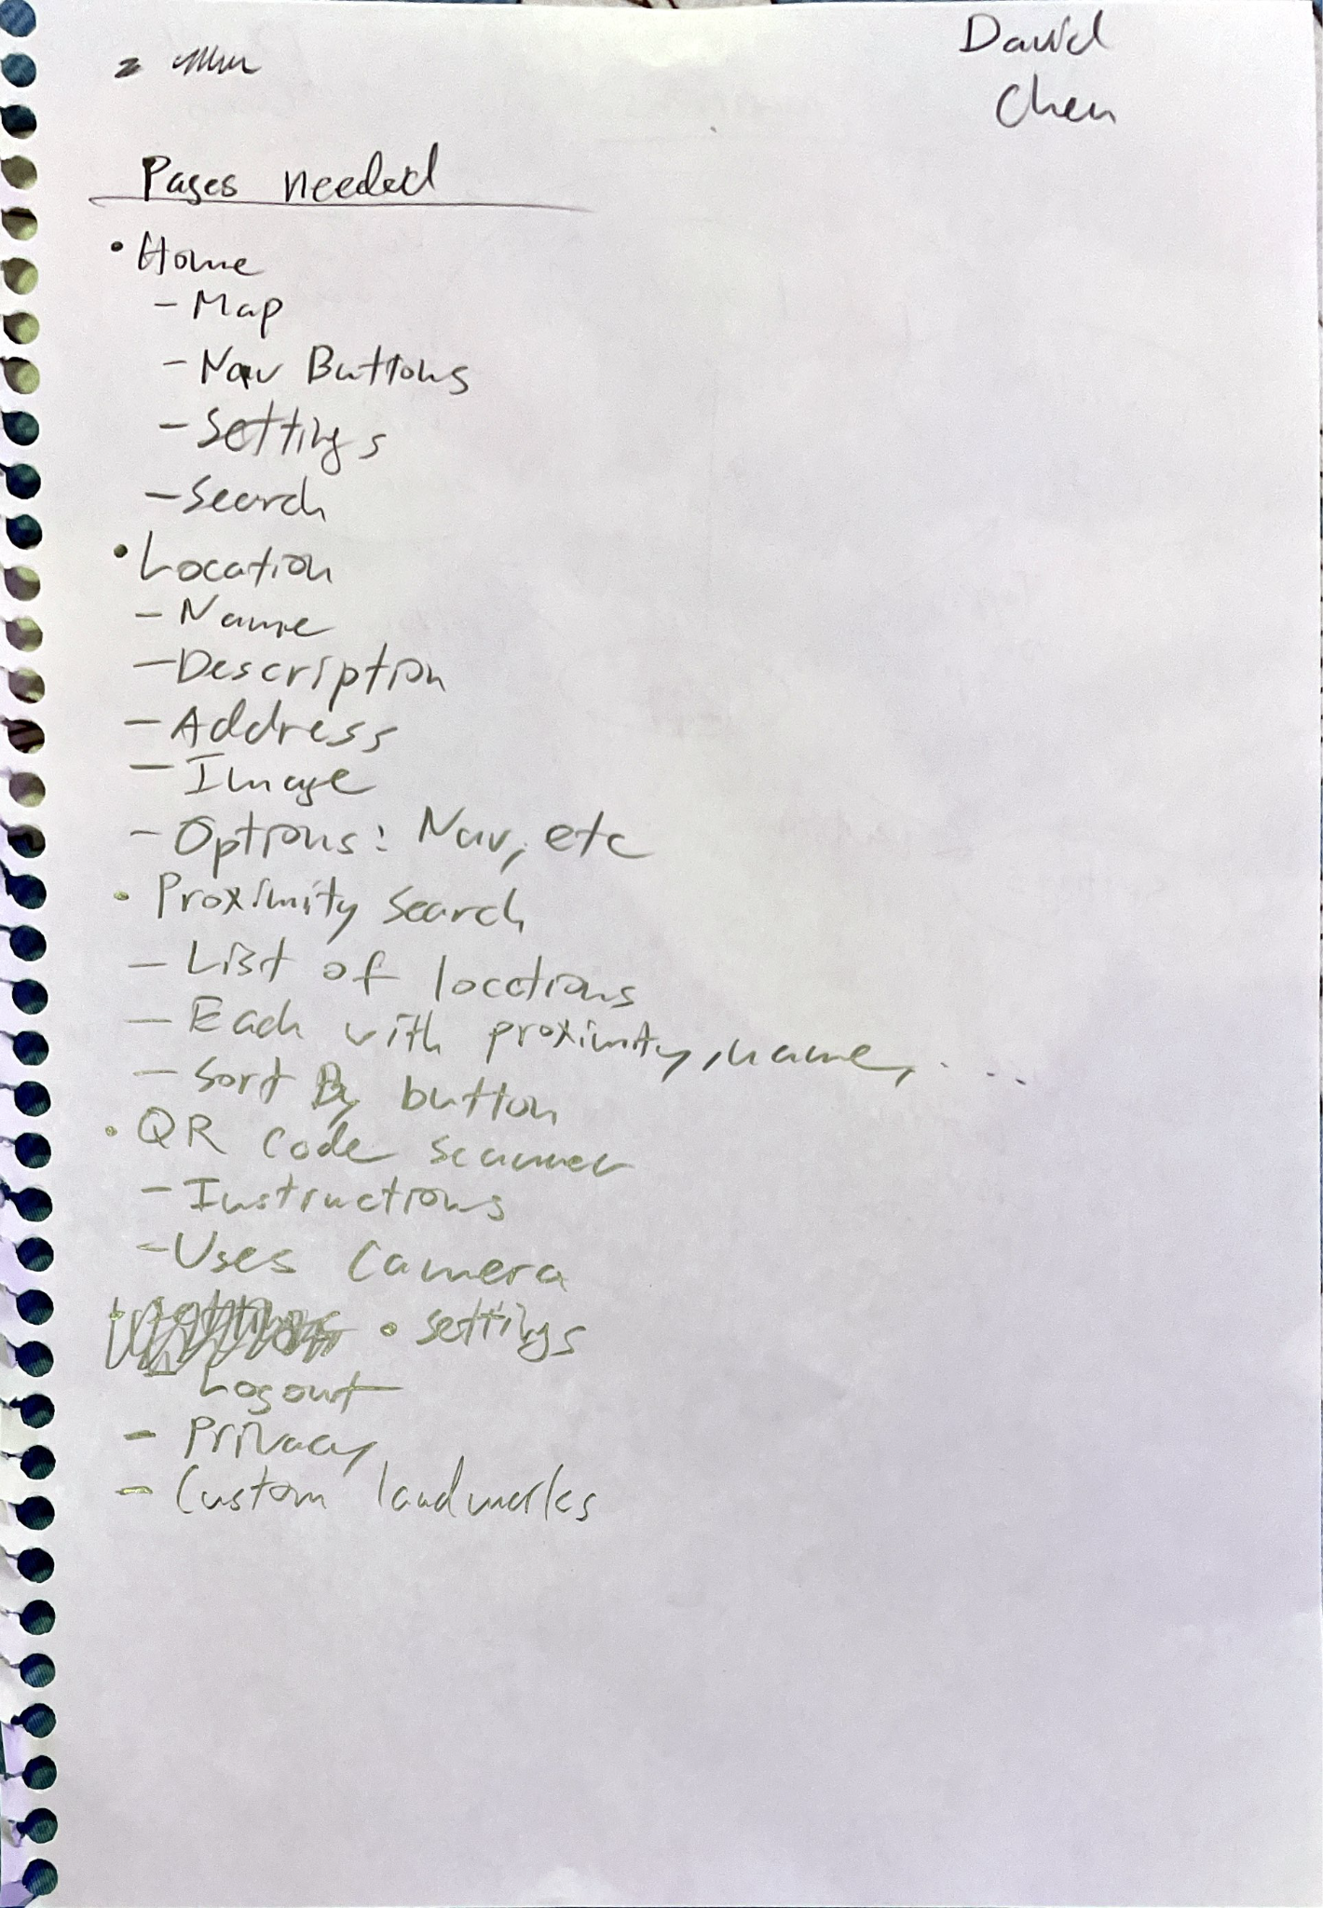

| Starting clockwise, the first image is a sketch of possible pages that the system would have. It would start with a main page that contains a map, centered on where the user is. There would be a navigation bar to take them to other pages like QR code scanner, list of nearby places or a search screen, and a page dedicated to a certain location.  Next is a graph for page transitions to illustrate how a user can get from one page to another. Arrows point to destinations with some information on how a user can get there. Depending on the platform, the user can use a back button to return to the previous page.  The final page is a brainstorm of possible pages for the system along with significant content that would need to appear on it. |
| --- |



**Evaluation Notes**

***Assets shared***

* Alexa’s storyboards

***Feedback***

* “A useful app”
* If she were to use it on campus, she would use it for eateries

o How busy are they right now?

o What’s on the current menu?

o Will this menu update depending on breakfast/lunch/dinner?

* Mentioned it should also track gender neutral bathrooms as well as the general ones
* There’s a risk of people spamming bad reviews if we give people the option to leave reviews at certain places
* Would be nice if it also marked hand sanitizer stations

***I asked***

* My roommate (UCI student, female, 3rd year)

***Changes in response***

* Ensure bathroom location feature tracks gender neutral bathrooms
* Mark additional landmarks such as hand sanitizing stations
* When tracking eateries, show the most updated menu

**Prototype**

*Main page*

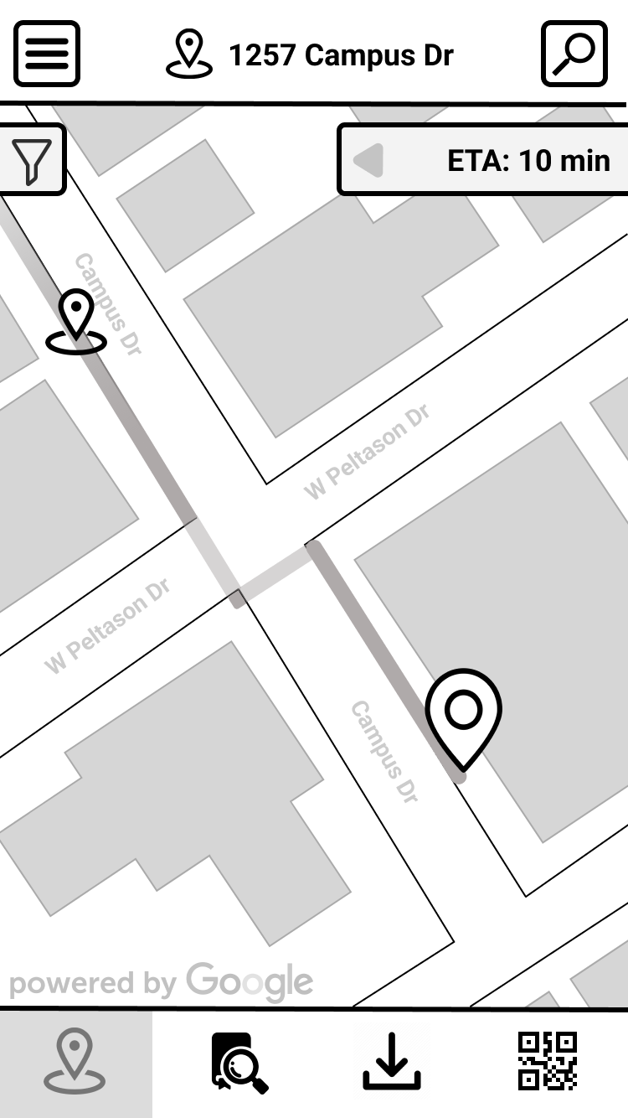

*QR page*

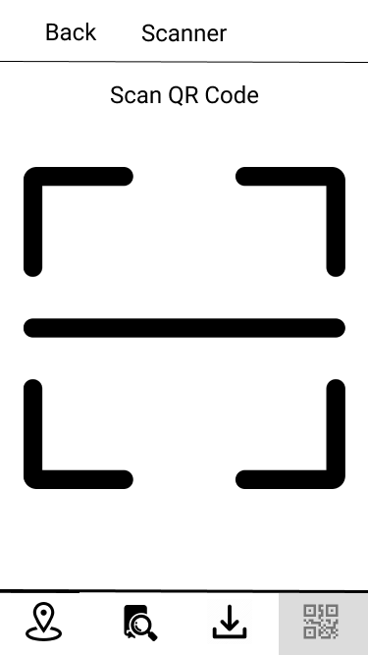

*Location Page*

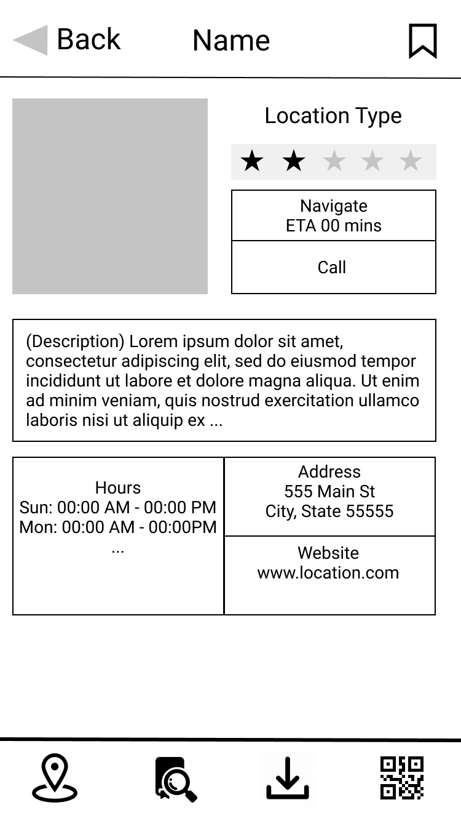

*Places of Interest page*

